The PM PCB is definitely more complex than the PG or BP so I’m sure some of my design constraints can be relaxed or may not even apply.

Here are my design rules for the rigid-flex PCB. They are acceptable for current manufacturing capabilities.

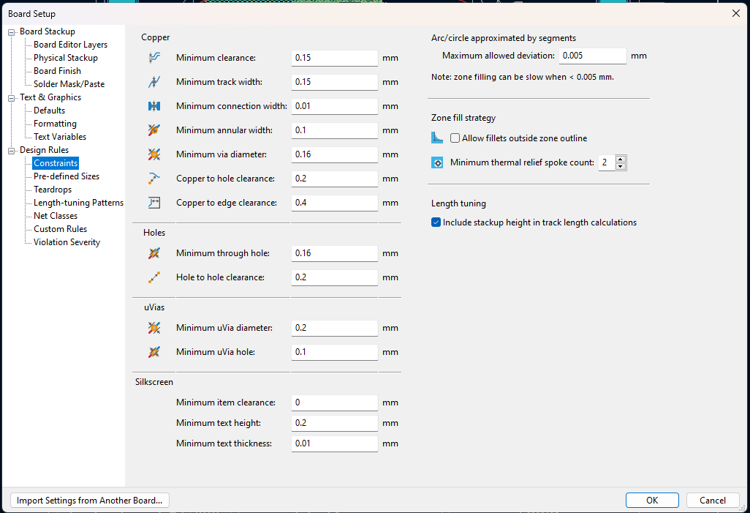

As for IPC Class 3, be sure to enable via teardrops as shown.

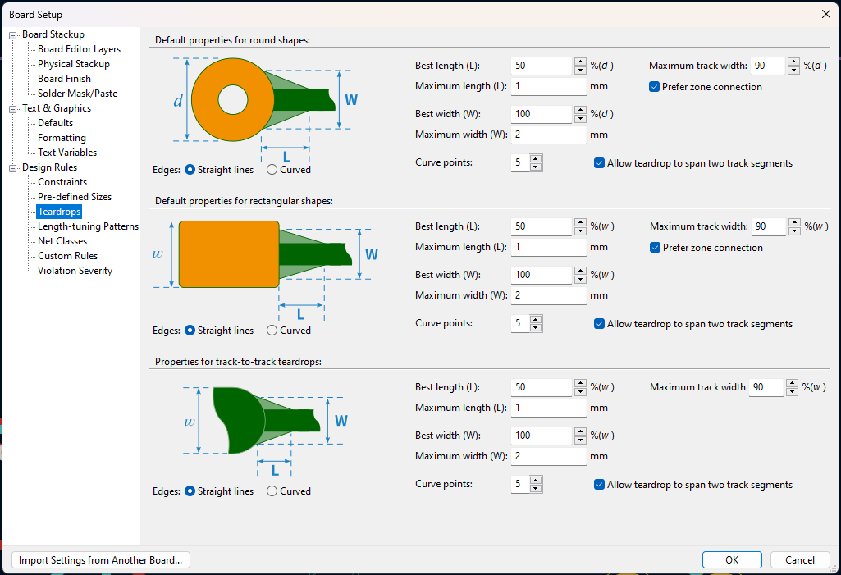

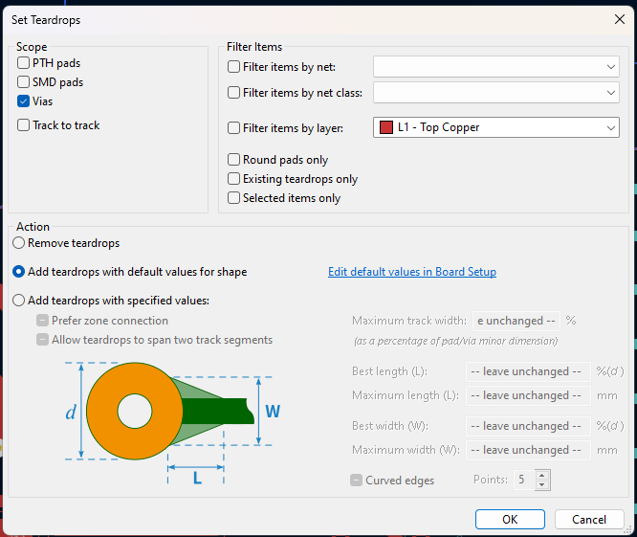

As for IPC Class 3, there were three specific potential reliability issues identified around the rigid-to-flex transition areas.

1 - Rule Areas were defined for each rigid-to-flex transition with a minimum width of 50mils. This is where the 50mils from rigid edge is important for the rigid-flex manufacturing process to meet Class 3.

In KiCAD, I setup the rule area for inner layers L3 thru L6. This way, blind vias L1-L2 and L7-L8 are still permitted in the area. The issue has to do with the adhesive for the flex coverlay expanding during solder reflow and potentially creating a latent defective crack in the feedthrough.

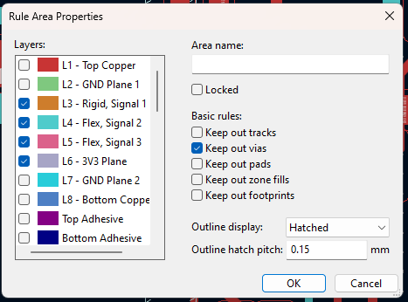

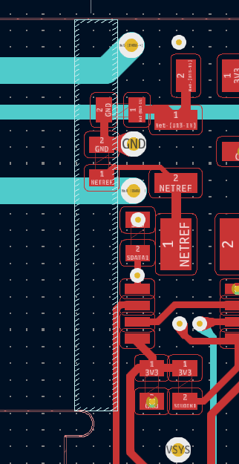

2 – There needs to be stress-relief at the flex layer transition corners. The board edge cut was changed to provide the stress-relief.

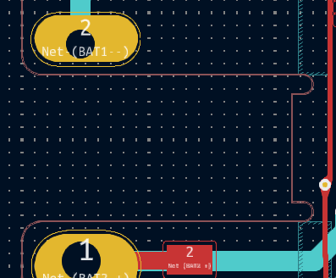

3.a. – The minimum flex area width is 3mm. Multiple manufacturers identified this as an issue for manufacturability and adequate bend radius to meet Class 3.

3.b. – Thus, the stiffener became problematic with its narrow flex widths and exceedingly tight bend radius. Post attachment of a stiffener is suggested, if necessary.

Any combination of these issues prevented manufacturers from quoting as Class 3.

